Rhode Island Testimonial Dinner
Honoring
Department Commander Department President
David Malone Linda Krogg

Saturday, November 2nd 2024

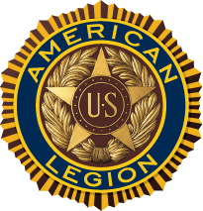
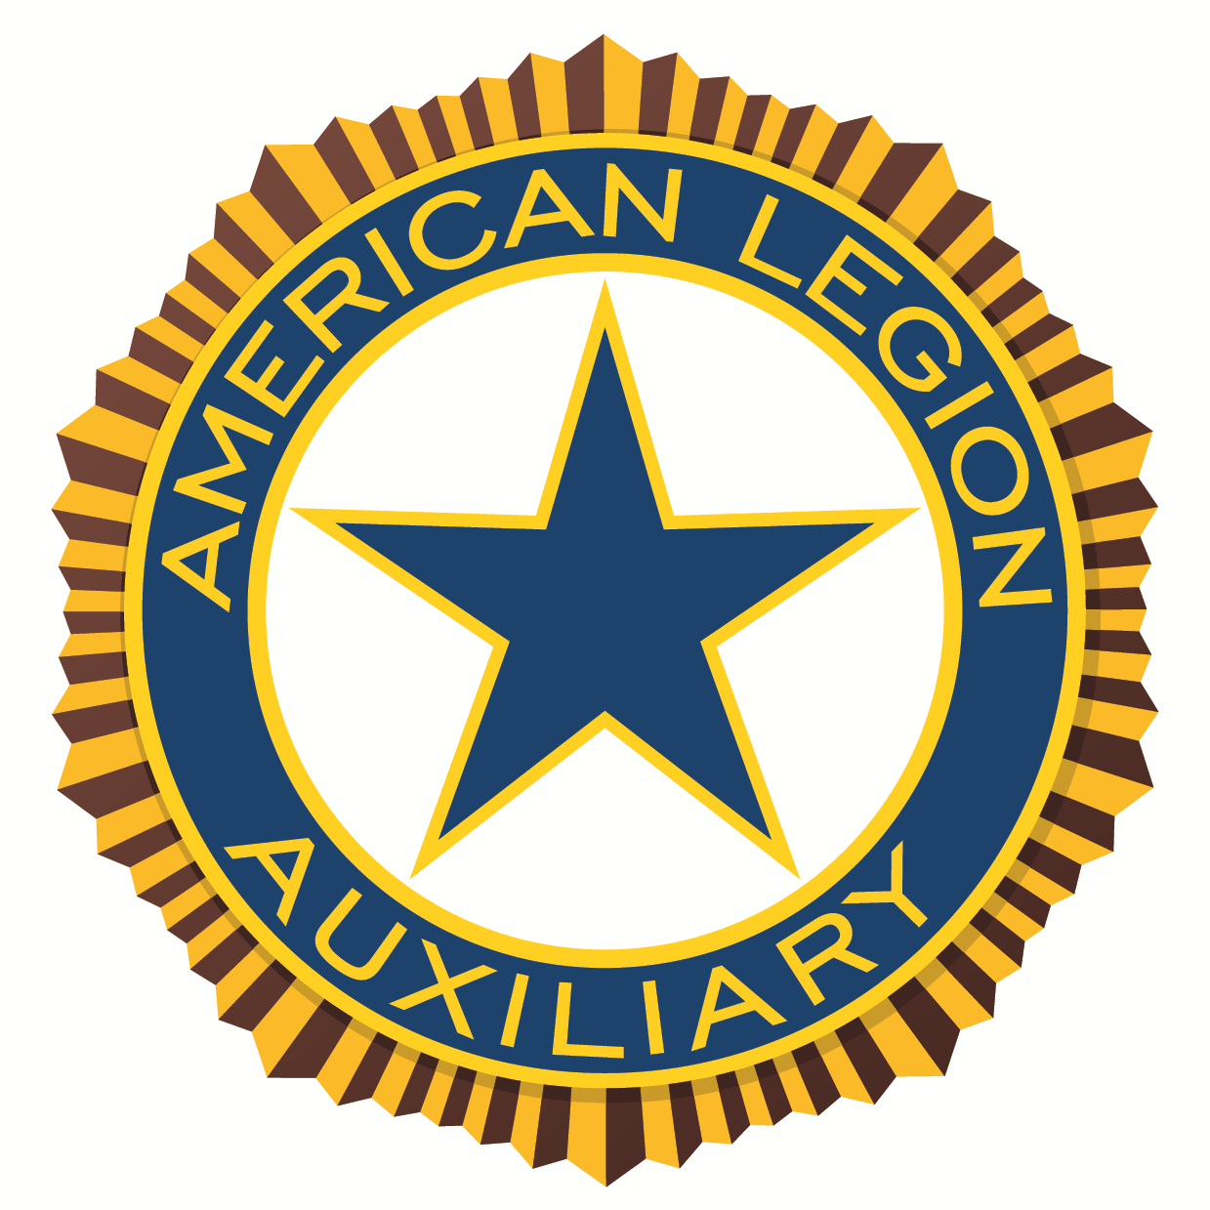
Twelve Acres
445 Douglas Pike
Smithfield RI 02917

Buffet Dinner to include:
Scrod, Chicken Marsella, Sliced Beef
Oven Roasted Potatoes, Rice Pilaf
Garden Vegetable Medley
Salad, Bread, Coffee and Tea

Cocktails 2:00 pm ~ Dinner 3:00 pm

NAME_____________________________________________________

MAILING ADDRESS__________________________________________

CITY____________________________STATE___________ZIP_______

TOTAL NUMBER OF TICKETS________Xs $50.00________________

TABLES ARE ROUNDS OF EIGHT / CUTOFF DATE IS October 25th 2024

SEND REQUEST WITH CHECK MADE OUT TO: THE AMERICAN LEGION
Mail to: Cory D Bates 18 Colorado St. Coventry RI 02816

