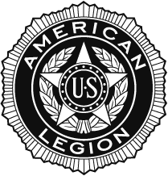

**The American Legion Department of Massachusetts**

**Department Commanders Banquet**

**Nelson Izaak Blake**

**Nonantum Post 440**

**295 California Street**

**Newton MA**

**Saturday, November 16, 2024**

**Social 3:00 PM Opening program 3:45 PM**

**Buffet 4:15 PM $50.00 PP**

**Pasta in a Plum Tomato Sauce**

**Hot Roast Beef Sirloin carved on buffet with gravy on side**

**Oven Roasted Potatoes**

**Long green beans with oil & garlic**

**Garden Salad**

**Dinner rolls & butter**

**Coffee & Tea Station**

**Assorted Miniature Pastry**

**Ticket Cutoff Date: October 28, 2024**

**Tables set for 10**

Business Casual (trousers and collared shirt for men and appropriate apparel dress for women)

**Dinner Reservations to: The American Legion Department of MA**

**State House RM 546-2**

**24 Beacon Street**

**Boston MA 02133**

**Department Testimonial**

**Check enclosed in the amount of $ _____________ for ___________**

**Name___________________________________________ Dept.__________**